**Funding Sources**

1. Managed Care Organizations (MCO)

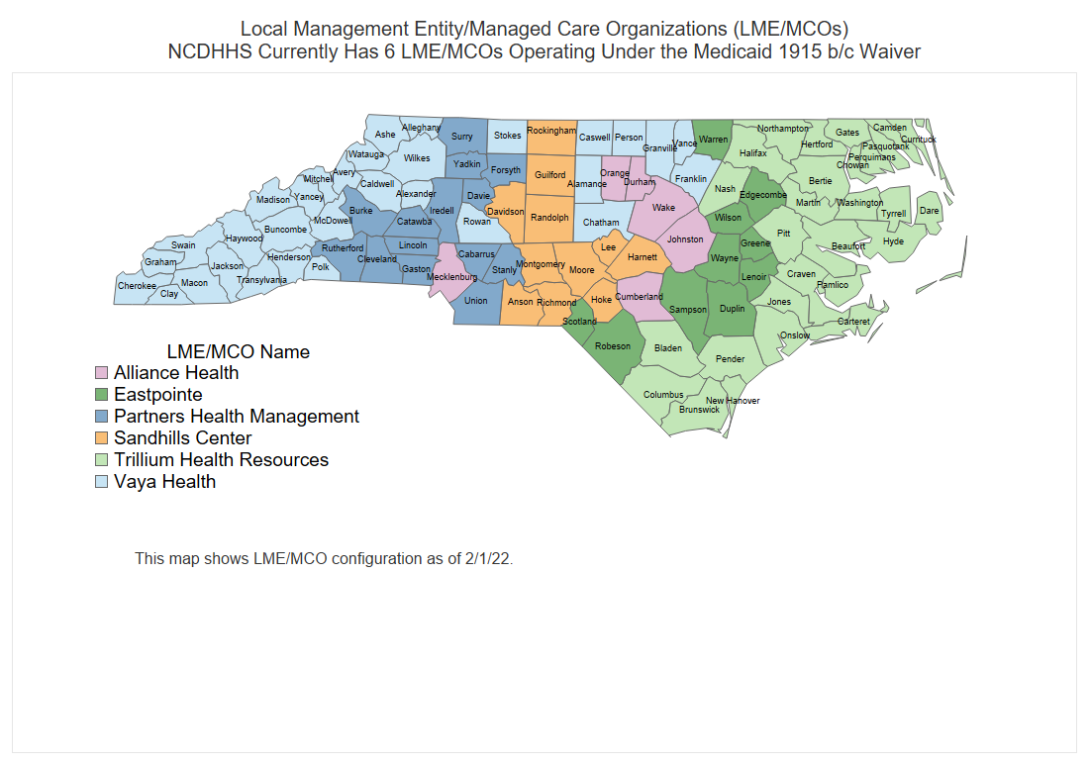

Funding through your local MCO might be available depending on the services you currently provide or are willing to provide. Examples of these services would be:

***Supported Employment (SE)(B3 Service)*** which provides assistance with choosing, acquiring, and maintaining employment for individuals ages 16 and older for whom competitive employment has not been achieved and/or has been interrupted or intermittent. B3 Services for individuals on Medicaid.

***Community Living Facilities and Supports (CLFS)*** consists of a broad range of services for adults with developmental disabilities who, through the Person-Centered Plan (PCP) process, choose to access active treatment to assist them with skills to live as independently as possible in the community.

***1:1 Day Support*** Day Supports is a service that provides assistance to individuals 16 years of age and older with acquisition, retention, or improvement in socialization and daily living skills and is one option for a meaningful day. The person-centered plan or individual support plan documents the supports needed based on the Support Needs Assessment Profile (SNAP), Supports Intensity Scale (SIS), and/or Traumatic Bain Injury (TBI) assessment(s).

1. Vocational Rehabilitation Services (VR) helps people with disabilities achieve their employment goals. If someone has a disability and wants to find a job, keep working or advance professionally, VR can help provide funding for additional industry-specific education and training, as well as provide funding for assistive technology. VR can also assist students with counseling and job placement.
2. Your local College Foundation- Ask about funding through your local college foundation.
3. Local Civic Organizations – Can provide funding for specific projects, materials, and in some cases, scholarships for students to enroll in and attend industry-recognized training programs.
4. Local churches – Churches are a tremendous resource when seeking funding and supports for specified needs of the IDD population. Transportation, scholarships, and materials are just a few of the ways churches can help programs.
5. Project Search – Project Search is a high school or young adult transition initiative which is a business-led, one-year, school-to-work program that combines classroom instruction, career exploration, and relevant job-skills training through strategically designed internships for students with intellectual and other developmental disabilities (I/DD). More information is available at www.projectsearch.us.